首先分为门票，选座， 无座， 三个主要场景。 这三个场景的UI 表现都不同，要实现的功能是一致的。

- 门票 （我以修改可售票组为例）

URL：https://anticket.lengliwh.com/mainframe/index.html#/mainrouter?projectLinkCode=e974c5ce21&&projectCodeId=e974c5ce21&pageUrl=%2Fmshow%2Findex.html%23%2Fmenpiao%2FnewPrograms

选择一个项目，比如 《大唐雅韵•钟鸣鼓乐》音乐会
点击button ‘ 详情’ 切换到时段Tab
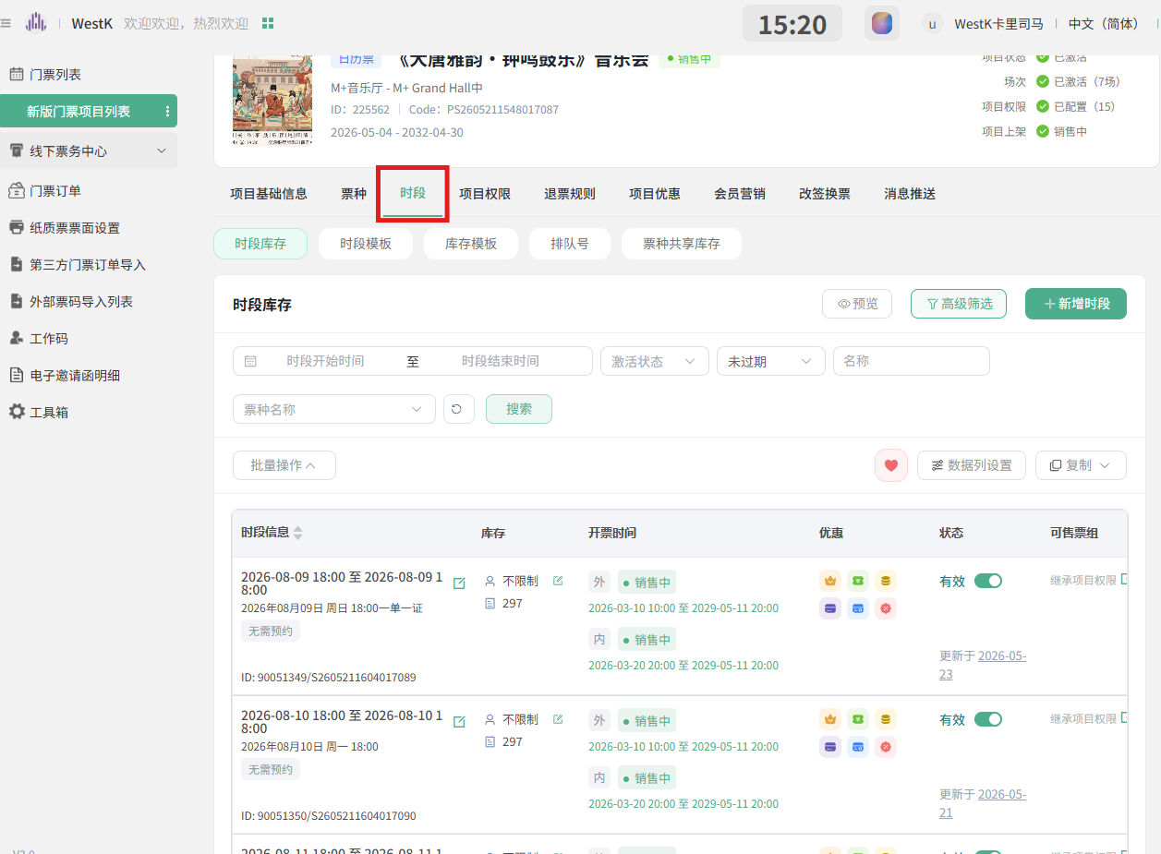
获取时段：
curl ^"https://anticket.lengliwh.com/theatre/home/openShow/listShowByTimeRange.xhtml?programId=225562^&fromDateTime=^&toDateTime=^&keyword=^&isExpired=N^&status=^" ^
-H ^"accept: application/json, text/plain, */*^" ^
-H ^"accept-language: zh-CN,zh;q=0.9^" ^
-H ^"cache-control: no-cache^" ^
-b ^"_c_WBKFRo=zQ8d6DeKcyJ7VL2MH7NE0GX5pJGSwyrJVhKxmMFA; fctkid=1782994118970_HRUH_bd05^@4EF8BBF145BC1BAD; Authorization=tbsNXR4N88VZXWhQF5dL4mTGdcc89528; ukeyage=1784778245570^" ^
-H ^"lang: zh-CN^" ^
-H ^"pragma: no-cache^" ^
-H ^"priority: u=1, i^" ^
-H ^"referer: https://anticket.lengliwh.com/mshow/index.html^" ^
-H ^"routerpath: mshow:/menpiao/newDetail/newSchedule^" ^
-H ^"sec-ch-ua: ^\^"Not;A=Brand^\^";v=^\^"8^\^", ^\^"Chromium^\^";v=^\^"150^\^", ^\^"Google Chrome^\^";v=^\^"150^\^"^" ^
-H ^"sec-ch-ua-mobile: ?0^" ^
-H ^"sec-ch-ua-platform: ^\^"Windows^\^"^" ^
-H ^"sec-fetch-dest: empty^" ^
-H ^"sec-fetch-mode: cors^" ^
-H ^"sec-fetch-site: same-origin^" ^
-H ^"user-agent: Mozilla/5.0 (Windows NT 10.0; Win64; x64) AppleWebKit/537.36 (KHTML, like Gecko) Chrome/150.0.0.0 Safari/537.36^"

批量修改可售票组
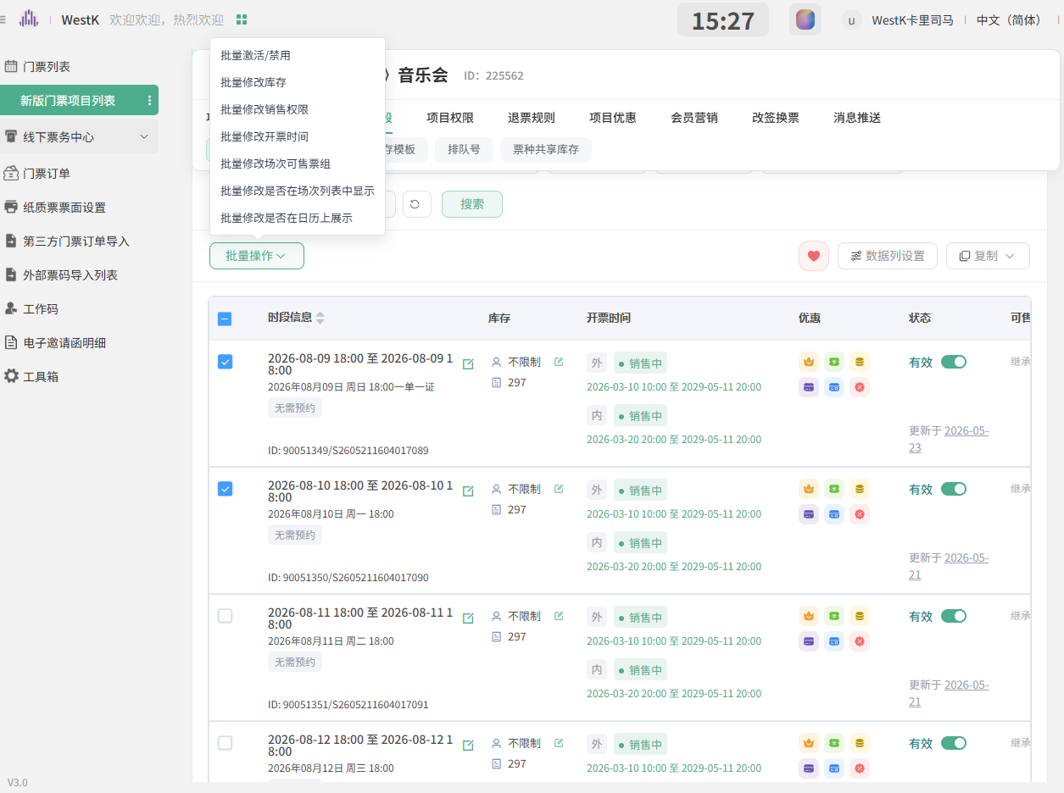

选择线上官网自营，提交
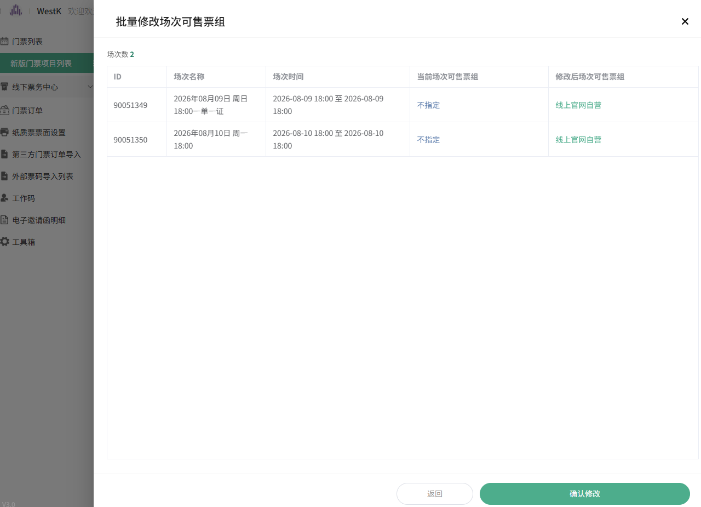

curl ^"https://anticket.lengliwh.com/theatre/home/openShow/op/batchSaveUserGroup.xhtml?showIds=90051349,90051350^&groups=57689^" ^
-X ^"POST^" ^
-H ^"accept: application/json, text/plain, */*^" ^
-H ^"accept-language: zh-CN,zh;q=0.9^" ^
-H ^"cache-control: no-cache^" ^
-H ^"content-length: 0^" ^
-b ^"_c_WBKFRo=zQ8d6DeKcyJ7VL2MH7NE0GX5pJGSwyrJVhKxmMFA; fctkid=1782994118970_HRUH_bd05^@4EF8BBF145BC1BAD; Authorization=tbsNXR4N88VZXWhQF5dL4mTGdcc89528; ukeyage=1784778245570^" ^
-H ^"lang: zh-CN^" ^
-H ^"origin: https://anticket.lengliwh.com^" ^
-H ^"pragma: no-cache^" ^
-H ^"priority: u=1, i^" ^
-H ^"referer: https://anticket.lengliwh.com/mshow/index.html^" ^
-H ^"routerpath: mshow:/menpiao/newDetail/newSchedule^" ^
-H ^"sec-ch-ua: ^\^"Not;A=Brand^\^";v=^\^"8^\^", ^\^"Chromium^\^";v=^\^"150^\^", ^\^"Google Chrome^\^";v=^\^"150^\^"^" ^
-H ^"sec-ch-ua-mobile: ?0^" ^
-H ^"sec-ch-ua-platform: ^\^"Windows^\^"^" ^
-H ^"sec-fetch-dest: empty^" ^
-H ^"sec-fetch-mode: cors^" ^
-H ^"sec-fetch-site: same-origin^" ^
-H ^"user-agent: Mozilla/5.0 (Windows NT 10.0; Win64; x64) AppleWebKit/537.36 (KHTML, like Gecko) Chrome/150.0.0.0 Safari/537.36^"

curl ^"https://anticket.lengliwh.com/theatre/home/openShow/listShowByTimeRange.xhtml?programId=225562^&fromDateTime=^&toDateTime=^&keyword=^&isExpired=N^&status=^" ^
-H ^"accept: application/json, text/plain, */*^" ^
-H ^"accept-language: zh-CN,zh;q=0.9^" ^
-H ^"cache-control: no-cache^" ^
-b ^"_c_WBKFRo=zQ8d6DeKcyJ7VL2MH7NE0GX5pJGSwyrJVhKxmMFA; fctkid=1782994118970_HRUH_bd05^@4EF8BBF145BC1BAD; Authorization=tbsNXR4N88VZXWhQF5dL4mTGdcc89528; ukeyage=1784778245570^" ^
-H ^"lang: zh-CN^" ^
-H ^"pragma: no-cache^" ^
-H ^"priority: u=1, i^" ^
-H ^"referer: https://anticket.lengliwh.com/mshow/index.html^" ^
-H ^"routerpath: mshow:/menpiao/newDetail/newSchedule^" ^
-H ^"sec-ch-ua: ^\^"Not;A=Brand^\^";v=^\^"8^\^", ^\^"Chromium^\^";v=^\^"150^\^", ^\^"Google Chrome^\^";v=^\^"150^\^"^" ^
-H ^"sec-ch-ua-mobile: ?0^" ^
-H ^"sec-ch-ua-platform: ^\^"Windows^\^"^" ^
-H ^"sec-fetch-dest: empty^" ^
-H ^"sec-fetch-mode: cors^" ^
-H ^"sec-fetch-site: same-origin^" ^
-H ^"user-agent: Mozilla/5.0 (Windows NT 10.0; Win64; x64) AppleWebKit/537.36 (KHTML, like Gecko) Chrome/150.0.0.0 Safari/537.36^"

- 选座 （我以修改场次列表中显示为例）
URL - https://anticket.lengliwh.com/mainframe/index.html#/mainrouter?projectLinkCode=0b19336cf4&projectCodeId=0b19336cf4&pageUrl=%2Fseatadmin%2Findex.html%23%2Fseat%2Fprograms

项目用这个- 明时·疗愈睡眠音乐会（行模式）(ID：225198)(编码：PS2603231551010309)

点击场次管理
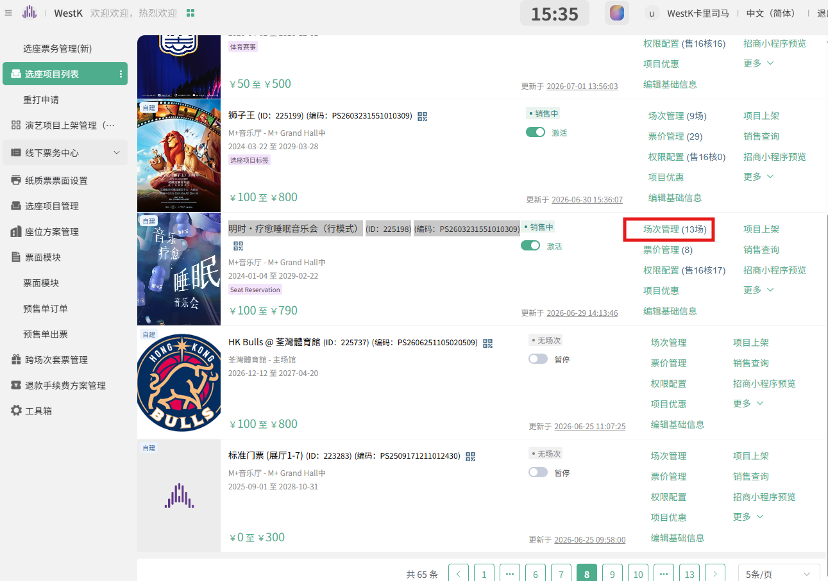

curl ^"https://anticket.lengliwh.com/theatre/home/ticket/program/get.xhtml?id=225198^" ^
-H ^"accept: application/json, text/plain, */*^" ^
-H ^"accept-language: zh-CN,zh;q=0.9^" ^
-H ^"cache-control: no-cache^" ^
-b ^"_c_WBKFRo=zQ8d6DeKcyJ7VL2MH7NE0GX5pJGSwyrJVhKxmMFA; fctkid=1782994118970_HRUH_bd05^@4EF8BBF145BC1BAD; Authorization=tbsNXR4N88VZXWhQF5dL4mTGdcc89528; ukeyage=1784778245570^" ^
-H ^"lang: zh-CN^" ^
-H ^"parentpath: seatadmin:/seat/programs^" ^
-H ^"pragma: no-cache^" ^
-H ^"priority: u=1, i^" ^
-H ^"referer: https://anticket.lengliwh.com/seatadmin/index.html^" ^
-H ^"routerpath: seatadmin:/seat/detail/schedule^" ^
-H ^"sec-ch-ua: ^\^"Not;A=Brand^\^";v=^\^"8^\^", ^\^"Chromium^\^";v=^\^"150^\^", ^\^"Google Chrome^\^";v=^\^"150^\^"^" ^
-H ^"sec-ch-ua-mobile: ?0^" ^
-H ^"sec-ch-ua-platform: ^\^"Windows^\^"^" ^
-H ^"sec-fetch-dest: empty^" ^
-H ^"sec-fetch-mode: cors^" ^
-H ^"sec-fetch-site: same-origin^" ^
-H ^"user-agent: Mozilla/5.0 (Windows NT 10.0; Win64; x64) AppleWebKit/537.36 (KHTML, like Gecko) Chrome/150.0.0.0 Safari/537.36^"

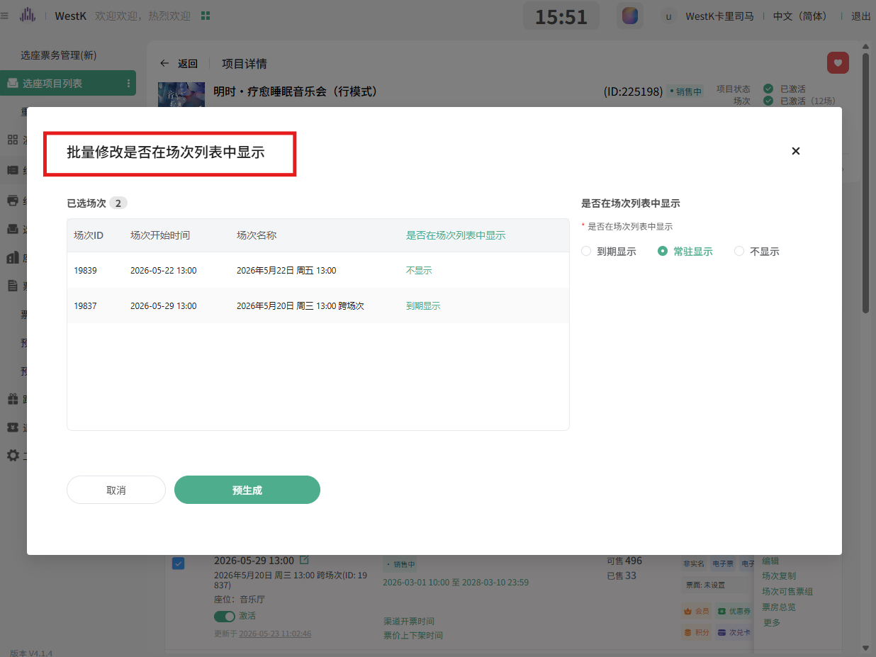

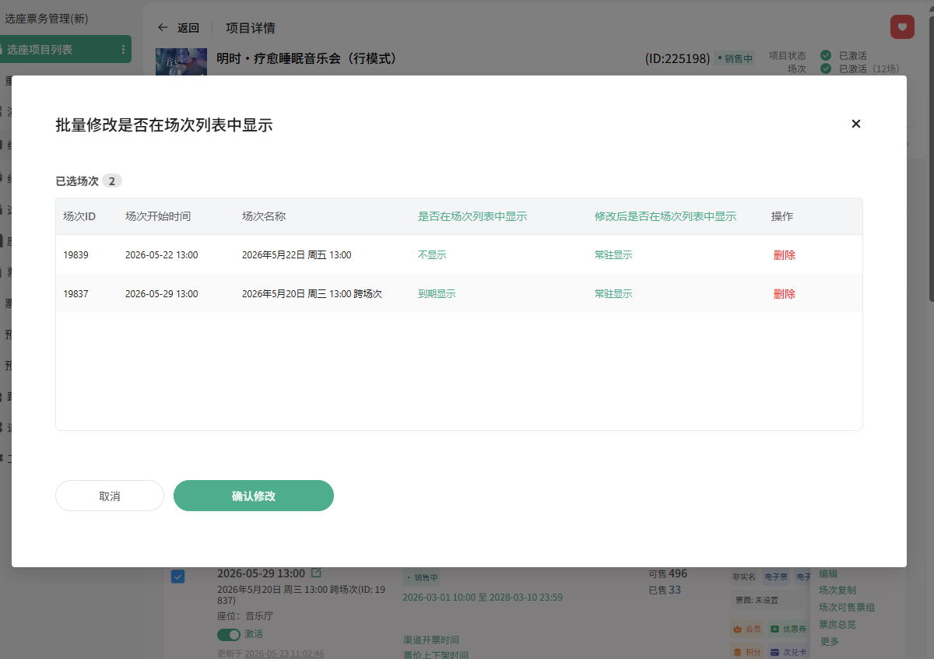

删除 =》 不触发API call， 确认修改，才会实际发送API参数

curl ^"https://anticket.lengliwh.com/theatre/home/schedule/op/batchUpdateDisplay.xhtml?scheduleIds=19839,19837^&display=Y^" ^
-X ^"POST^" ^
-H ^"accept: application/json, text/plain, */*^" ^
-H ^"accept-language: zh-CN,zh;q=0.9^" ^
-H ^"cache-control: no-cache^" ^
-H ^"content-length: 0^" ^
-b ^"_c_WBKFRo=zQ8d6DeKcyJ7VL2MH7NE0GX5pJGSwyrJVhKxmMFA; fctkid=1782994118970_HRUH_bd05^@4EF8BBF145BC1BAD; Authorization=tbsNXR4N88VZXWhQF5dL4mTGdcc89528; ukeyage=1784778245570^" ^
-H ^"lang: zh-CN^" ^
-H ^"origin: https://anticket.lengliwh.com^" ^
-H ^"parentpath: seatadmin:/seat/programs^" ^
-H ^"pragma: no-cache^" ^
-H ^"priority: u=1, i^" ^
-H ^"referer: https://anticket.lengliwh.com/seatadmin/index.html^" ^
-H ^"routerpath: seatadmin:/seat/detail/schedule^" ^
-H ^"sec-ch-ua: ^\^"Not;A=Brand^\^";v=^\^"8^\^", ^\^"Chromium^\^";v=^\^"150^\^", ^\^"Google Chrome^\^";v=^\^"150^\^"^" ^
-H ^"sec-ch-ua-mobile: ?0^" ^
-H ^"sec-ch-ua-platform: ^\^"Windows^\^"^" ^
-H ^"sec-fetch-dest: empty^" ^
-H ^"sec-fetch-mode: cors^" ^
-H ^"sec-fetch-site: same-origin^" ^
-H ^"user-agent: Mozilla/5.0 (Windows NT 10.0; Win64; x64) AppleWebKit/537.36 (KHTML, like Gecko) Chrome/150.0.0.0 Safari/537.36^"

curl ^"https://anticket.lengliwh.com/theatre/home/schedule/list.xhtml?programId=225198^&playTimeFrom=^&playTimeEnd=^&keyword=^&scheduleId=^&status=^&overdue=^&ticketTypeIds=^&pageNo=1^&pageSize=10^" ^
-H ^"accept: application/json, text/plain, */*^" ^
-H ^"accept-language: zh-CN,zh;q=0.9^" ^
-H ^"cache-control: no-cache^" ^
-b ^"_c_WBKFRo=zQ8d6DeKcyJ7VL2MH7NE0GX5pJGSwyrJVhKxmMFA; fctkid=1782994118970_HRUH_bd05^@4EF8BBF145BC1BAD; Authorization=tbsNXR4N88VZXWhQF5dL4mTGdcc89528; ukeyage=1784778245570^" ^
-H ^"lang: zh-CN^" ^
-H ^"parentpath: seatadmin:/seat/programs^" ^
-H ^"pragma: no-cache^" ^
-H ^"priority: u=1, i^" ^
-H ^"referer: https://anticket.lengliwh.com/seatadmin/index.html^" ^
-H ^"routerpath: seatadmin:/seat/detail/schedule^" ^
-H ^"sec-ch-ua: ^\^"Not;A=Brand^\^";v=^\^"8^\^", ^\^"Chromium^\^";v=^\^"150^\^", ^\^"Google Chrome^\^";v=^\^"150^\^"^" ^
-H ^"sec-ch-ua-mobile: ?0^" ^
-H ^"sec-ch-ua-platform: ^\^"Windows^\^"^" ^
-H ^"sec-fetch-dest: empty^" ^
-H ^"sec-fetch-mode: cors^" ^
-H ^"sec-fetch-site: same-origin^" ^
-H ^"user-agent: Mozilla/5.0 (Windows NT 10.0; Win64; x64) AppleWebKit/537.36 (KHTML, like Gecko) Chrome/150.0.0.0 Safari/537.36^"

curl ^"https://anticket.lengliwh.com/theatre/home/ticket/program/get.xhtml?id=225198^" ^
-H ^"accept: application/json, text/plain, */*^" ^
-H ^"accept-language: zh-CN,zh;q=0.9^" ^
-H ^"cache-control: no-cache^" ^
-b ^"_c_WBKFRo=zQ8d6DeKcyJ7VL2MH7NE0GX5pJGSwyrJVhKxmMFA; fctkid=1782994118970_HRUH_bd05^@4EF8BBF145BC1BAD; Authorization=tbsNXR4N88VZXWhQF5dL4mTGdcc89528; ukeyage=1784778245570^" ^
-H ^"lang: zh-CN^" ^
-H ^"parentpath: seatadmin:/seat/programs^" ^
-H ^"pragma: no-cache^" ^
-H ^"priority: u=1, i^" ^
-H ^"referer: https://anticket.lengliwh.com/seatadmin/index.html^" ^
-H ^"routerpath: seatadmin:/seat/detail/schedule^" ^
-H ^"sec-ch-ua: ^\^"Not;A=Brand^\^";v=^\^"8^\^", ^\^"Chromium^\^";v=^\^"150^\^", ^\^"Google Chrome^\^";v=^\^"150^\^"^" ^
-H ^"sec-ch-ua-mobile: ?0^" ^
-H ^"sec-ch-ua-platform: ^\^"Windows^\^"^" ^
-H ^"sec-fetch-dest: empty^" ^
-H ^"sec-fetch-mode: cors^" ^
-H ^"sec-fetch-site: same-origin^" ^
-H ^"user-agent: Mozilla/5.0 (Windows NT 10.0; Win64; x64) AppleWebKit/537.36 (KHTML, like Gecko) Chrome/150.0.0.0 Safari/537.36^"

点击 编辑 - 去获取字段编辑展示页， 展开高级设置。

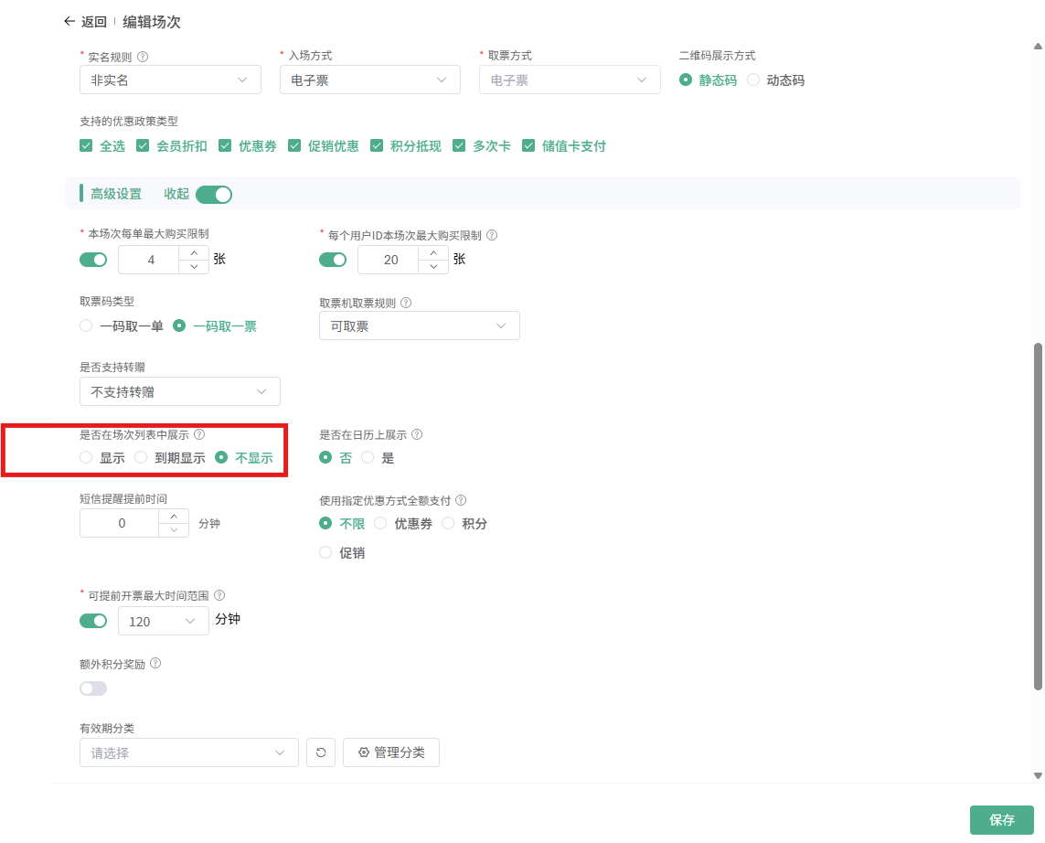

curl ^"https://anticket.lengliwh.com/theatre/home/schedule/get.xhtml?id=19838^" ^
-H ^"accept: application/json, text/plain, */*^" ^
-H ^"accept-language: zh-CN,zh;q=0.9^" ^
-H ^"cache-control: no-cache^" ^
-b ^"_c_WBKFRo=zQ8d6DeKcyJ7VL2MH7NE0GX5pJGSwyrJVhKxmMFA; fctkid=1782994118970_HRUH_bd05^@4EF8BBF145BC1BAD; Authorization=tbsNXR4N88VZXWhQF5dL4mTGdcc89528; ukeyage=1784778245570^" ^
-H ^"lang: zh-CN^" ^
-H ^"parentpath: seatadmin:/seat/programs^" ^
-H ^"pragma: no-cache^" ^
-H ^"priority: u=1, i^" ^
-H ^"referer: https://anticket.lengliwh.com/seatadmin/index.html^" ^
-H ^"routerpath: seatadmin:/seat/detail/schedule^" ^
-H ^"sec-ch-ua: ^\^"Not;A=Brand^\^";v=^\^"8^\^", ^\^"Chromium^\^";v=^\^"150^\^", ^\^"Google Chrome^\^";v=^\^"150^\^"^" ^
-H ^"sec-ch-ua-mobile: ?0^" ^
-H ^"sec-ch-ua-platform: ^\^"Windows^\^"^" ^
-H ^"sec-fetch-dest: empty^" ^
-H ^"sec-fetch-mode: cors^" ^
-H ^"sec-fetch-site: same-origin^" ^
-H ^"user-agent: Mozilla/5.0 (Windows NT 10.0; Win64; x64) AppleWebKit/537.36 (KHTML, like Gecko) Chrome/150.0.0.0 Safari/537.36^"

curl ^"https://anticket.lengliwh.com/theatre/home/layout/list.xhtml?name=^&flag=^&pageNo=1^&pageSize=100000^&notIncludeStadiumId=Y^&stadiumId=69632^&buId=25^" ^
-H ^"accept: application/json, text/plain, */*^" ^
-H ^"accept-language: zh-CN,zh;q=0.9^" ^
-H ^"cache-control: no-cache^" ^
-b ^"_c_WBKFRo=zQ8d6DeKcyJ7VL2MH7NE0GX5pJGSwyrJVhKxmMFA; fctkid=1782994118970_HRUH_bd05^@4EF8BBF145BC1BAD; Authorization=tbsNXR4N88VZXWhQF5dL4mTGdcc89528; ukeyage=1784778245570^" ^
-H ^"lang: zh-CN^" ^
-H ^"parentpath: seatadmin:/seat/programs^" ^
-H ^"pragma: no-cache^" ^
-H ^"priority: u=1, i^" ^
-H ^"referer: https://anticket.lengliwh.com/seatadmin/index.html^" ^
-H ^"routerpath: seatadmin:/seat/detail/schedule^" ^
-H ^"sec-ch-ua: ^\^"Not;A=Brand^\^";v=^\^"8^\^", ^\^"Chromium^\^";v=^\^"150^\^", ^\^"Google Chrome^\^";v=^\^"150^\^"^" ^
-H ^"sec-ch-ua-mobile: ?0^" ^
-H ^"sec-ch-ua-platform: ^\^"Windows^\^"^" ^
-H ^"sec-fetch-dest: empty^" ^
-H ^"sec-fetch-mode: cors^" ^
-H ^"sec-fetch-site: same-origin^" ^
-H ^"user-agent: Mozilla/5.0 (Windows NT 10.0; Win64; x64) AppleWebKit/537.36 (KHTML, like Gecko) Chrome/150.0.0.0 Safari/537.36^"

无座：（我以修改日历上展示）
URL ： https://anticket.lengliwh.com/mainframe/index.html#/mainrouter?projectLinkCode=44514e45ed&projectCodeId=44514e45ed&pageUrl=%2Fmshow%2Findex.html%23%2Fmenpiao%2Fprograms
项目用这个- 测试项目A
(ID:223334)

点击场次管理
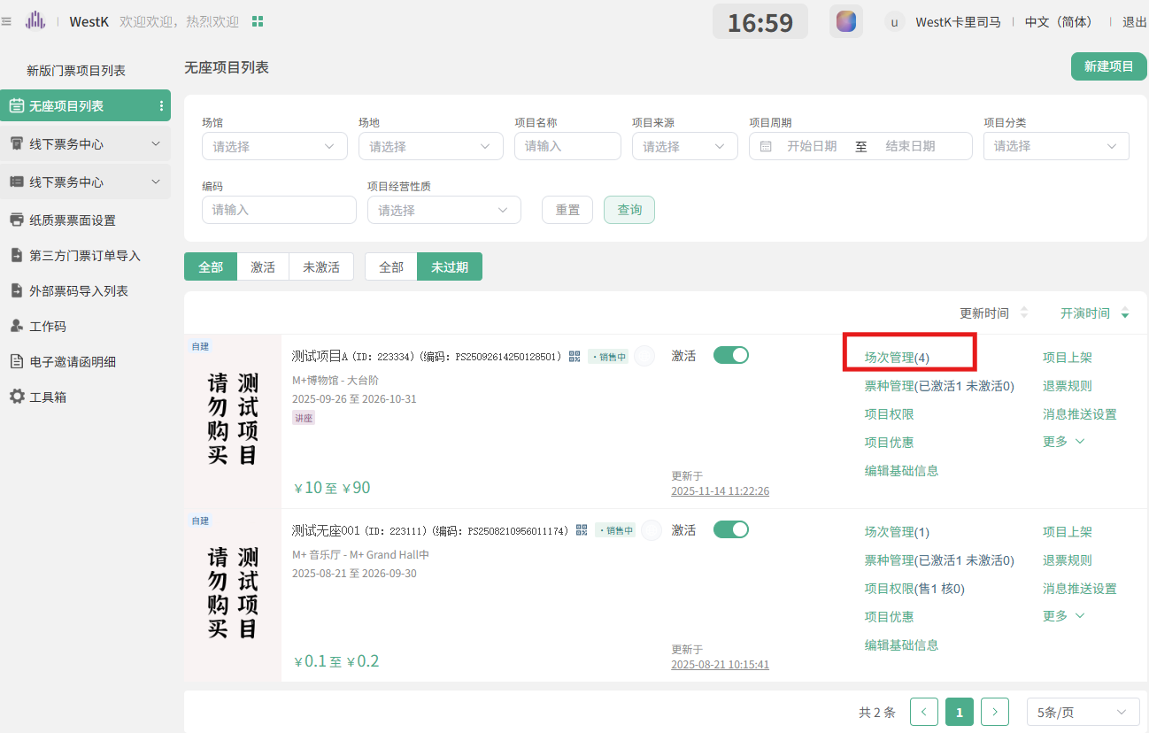

筛选出全部场次

curl ^"https://anticket.lengliwh.com/theatre/home/openShow/list.xhtml?programId=223334^&pageSize=2000^" ^
-H ^"accept: application/json, text/plain, */*^" ^
-H ^"accept-language: zh-CN,zh;q=0.9^" ^
-H ^"cache-control: no-cache^" ^
-b ^"_c_WBKFRo=zQ8d6DeKcyJ7VL2MH7NE0GX5pJGSwyrJVhKxmMFA; fctkid=1782994118970_HRUH_bd05^@4EF8BBF145BC1BAD; Authorization=tbsNXR4N88VZXWhQF5dL4mTGdcc89528; ukeyage=1784778245570^" ^
-H ^"lang: zh-CN^" ^
-H ^"parentpath: mshow:/menpiao/programs^" ^
-H ^"pragma: no-cache^" ^
-H ^"priority: u=1, i^" ^
-H ^"referer: https://anticket.lengliwh.com/mshow/index.html^" ^
-H ^"routerpath: mshow:/menpiao/detail/schedule^" ^
-H ^"sec-ch-ua: ^\^"Not;A=Brand^\^";v=^\^"8^\^", ^\^"Chromium^\^";v=^\^"150^\^", ^\^"Google Chrome^\^";v=^\^"150^\^"^" ^
-H ^"sec-ch-ua-mobile: ?0^" ^
-H ^"sec-ch-ua-platform: ^\^"Windows^\^"^" ^
-H ^"sec-fetch-dest: empty^" ^
-H ^"sec-fetch-mode: cors^" ^
-H ^"sec-fetch-site: same-origin^" ^
-H ^"user-agent: Mozilla/5.0 (Windows NT 10.0; Win64; x64) AppleWebKit/537.36 (KHTML, like Gecko) Chrome/150.0.0.0 Safari/537.36^" &
curl ^"https://anticket.lengliwh.com/theatre/home/openShow/listShowByTimeRange.xhtml?programId=223334^&fromDateTime=^&toDateTime=^&keyword=^&isExpired=^&status=^&ticketTypeIds=^" ^
-H ^"accept: application/json, text/plain, */*^" ^
-H ^"accept-language: zh-CN,zh;q=0.9^" ^
-H ^"cache-control: no-cache^" ^
-b ^"_c_WBKFRo=zQ8d6DeKcyJ7VL2MH7NE0GX5pJGSwyrJVhKxmMFA; fctkid=1782994118970_HRUH_bd05^@4EF8BBF145BC1BAD; Authorization=tbsNXR4N88VZXWhQF5dL4mTGdcc89528; ukeyage=1784778245570^" ^
-H ^"lang: zh-CN^" ^
-H ^"parentpath: mshow:/menpiao/programs^" ^
-H ^"pragma: no-cache^" ^
-H ^"priority: u=1, i^" ^
-H ^"referer: https://anticket.lengliwh.com/mshow/index.html^" ^
-H ^"routerpath: mshow:/menpiao/detail/schedule^" ^
-H ^"sec-ch-ua: ^\^"Not;A=Brand^\^";v=^\^"8^\^", ^\^"Chromium^\^";v=^\^"150^\^", ^\^"Google Chrome^\^";v=^\^"150^\^"^" ^
-H ^"sec-ch-ua-mobile: ?0^" ^
-H ^"sec-ch-ua-platform: ^\^"Windows^\^"^" ^
-H ^"sec-fetch-dest: empty^" ^
-H ^"sec-fetch-mode: cors^" ^
-H ^"sec-fetch-site: same-origin^" ^
-H ^"user-agent: Mozilla/5.0 (Windows NT 10.0; Win64; x64) AppleWebKit/537.36 (KHTML, like Gecko) Chrome/150.0.0.0 Safari/537.36^"

批量修改
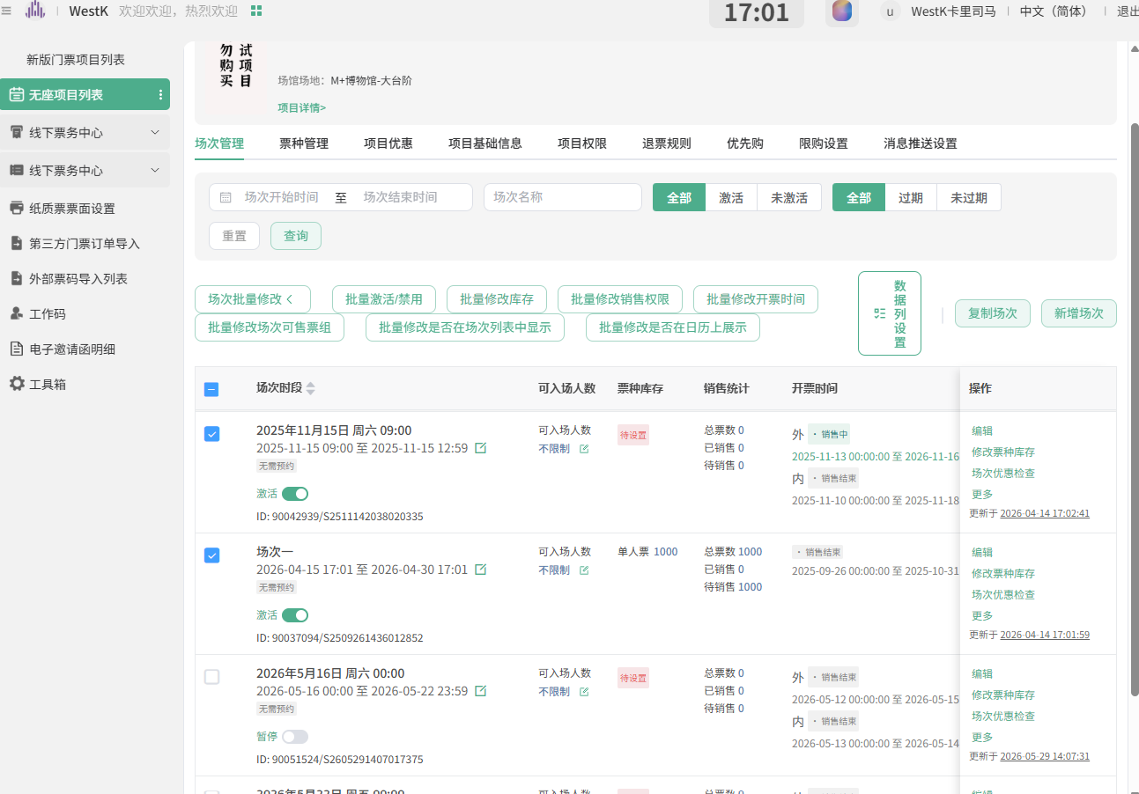

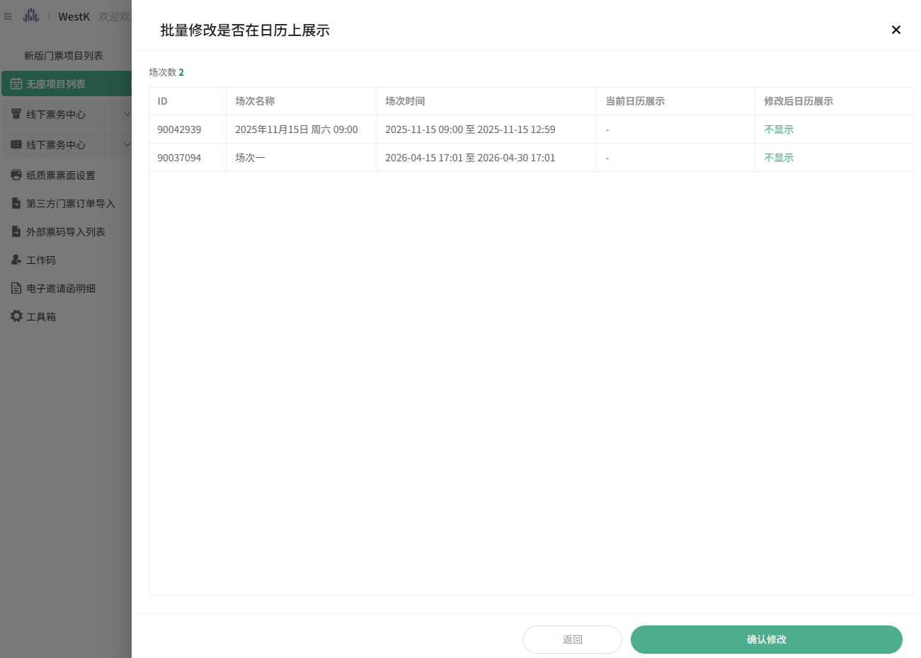

curl ^"https://anticket.lengliwh.com/theatre/home/openShow/op/batchUpdateShowCalendar.xhtml?showIds=90042939,90037094^&showCalendar=N^" ^
-X ^"POST^" ^
-H ^"accept: application/json, text/plain, */*^" ^
-H ^"accept-language: zh-CN,zh;q=0.9^" ^
-H ^"cache-control: no-cache^" ^
-H ^"content-length: 0^" ^
-b ^"_c_WBKFRo=zQ8d6DeKcyJ7VL2MH7NE0GX5pJGSwyrJVhKxmMFA; fctkid=1782994118970_HRUH_bd05^@4EF8BBF145BC1BAD; Authorization=tbsNXR4N88VZXWhQF5dL4mTGdcc89528; ukeyage=1784778245570^" ^
-H ^"lang: zh-CN^" ^
-H ^"origin: https://anticket.lengliwh.com^" ^
-H ^"parentpath: mshow:/menpiao/programs^" ^
-H ^"pragma: no-cache^" ^
-H ^"priority: u=1, i^" ^
-H ^"referer: https://anticket.lengliwh.com/mshow/index.html^" ^
-H ^"routerpath: mshow:/menpiao/detail/schedule^" ^
-H ^"sec-ch-ua: ^\^"Not;A=Brand^\^";v=^\^"8^\^", ^\^"Chromium^\^";v=^\^"150^\^", ^\^"Google Chrome^\^";v=^\^"150^\^"^" ^
-H ^"sec-ch-ua-mobile: ?0^" ^
-H ^"sec-ch-ua-platform: ^\^"Windows^\^"^" ^
-H ^"sec-fetch-dest: empty^" ^
-H ^"sec-fetch-mode: cors^" ^
-H ^"sec-fetch-site: same-origin^" ^
-H ^"user-agent: Mozilla/5.0 (Windows NT 10.0; Win64; x64) AppleWebKit/537.36 (KHTML, like Gecko) Chrome/150.0.0.0 Safari/537.36^"

返回，点击编辑 ，展开高级设置， 检查字段是否被修改。

curl ^"https://anticket.lengliwh.com/theatre/home/param/getShowPrice.xhtml^" ^
-H ^"accept: application/json, text/plain, */*^" ^
-H ^"accept-language: zh-CN,zh;q=0.9^" ^
-H ^"cache-control: no-cache^" ^
-b ^"_c_WBKFRo=zQ8d6DeKcyJ7VL2MH7NE0GX5pJGSwyrJVhKxmMFA; fctkid=1782994118970_HRUH_bd05^@4EF8BBF145BC1BAD; Authorization=tbsNXR4N88VZXWhQF5dL4mTGdcc89528; ukeyage=1784778245570^" ^
-H ^"lang: zh-CN^" ^
-H ^"parentpath: mshow:/menpiao/programs^" ^
-H ^"pragma: no-cache^" ^
-H ^"priority: u=1, i^" ^
-H ^"referer: https://anticket.lengliwh.com/mshow/index.html^" ^
-H ^"routerpath: mshow:/menpiao/detail/schedule^" ^
-H ^"sec-ch-ua: ^\^"Not;A=Brand^\^";v=^\^"8^\^", ^\^"Chromium^\^";v=^\^"150^\^", ^\^"Google Chrome^\^";v=^\^"150^\^"^" ^
-H ^"sec-ch-ua-mobile: ?0^" ^
-H ^"sec-ch-ua-platform: ^\^"Windows^\^"^" ^
-H ^"sec-fetch-dest: empty^" ^
-H ^"sec-fetch-mode: cors^" ^
-H ^"sec-fetch-site: same-origin^" ^
-H ^"user-agent: Mozilla/5.0 (Windows NT 10.0; Win64; x64) AppleWebKit/537.36 (KHTML, like Gecko) Chrome/150.0.0.0 Safari/537.36^"

curl ^"https://anticket.lengliwh.com/theatre/home/openShow/get.xhtml?id=90042939^" ^
-H ^"accept: application/json, text/plain, */*^" ^
-H ^"accept-language: zh-CN,zh;q=0.9^" ^
-H ^"cache-control: no-cache^" ^
-b ^"_c_WBKFRo=zQ8d6DeKcyJ7VL2MH7NE0GX5pJGSwyrJVhKxmMFA; fctkid=1782994118970_HRUH_bd05^@4EF8BBF145BC1BAD; Authorization=tbsNXR4N88VZXWhQF5dL4mTGdcc89528; ukeyage=1784778245570^" ^
-H ^"lang: zh-CN^" ^
-H ^"parentpath: mshow:/menpiao/programs^" ^
-H ^"pragma: no-cache^" ^
-H ^"priority: u=1, i^" ^
-H ^"referer: https://anticket.lengliwh.com/mshow/index.html^" ^
-H ^"routerpath: mshow:/menpiao/detail/schedule^" ^
-H ^"sec-ch-ua: ^\^"Not;A=Brand^\^";v=^\^"8^\^", ^\^"Chromium^\^";v=^\^"150^\^", ^\^"Google Chrome^\^";v=^\^"150^\^"^" ^
-H ^"sec-ch-ua-mobile: ?0^" ^
-H ^"sec-ch-ua-platform: ^\^"Windows^\^"^" ^
-H ^"sec-fetch-dest: empty^" ^
-H ^"sec-fetch-mode: cors^" ^
-H ^"sec-fetch-site: same-origin^" ^
-H ^"user-agent: Mozilla/5.0 (Windows NT 10.0; Win64; x64) AppleWebKit/537.36 (KHTML, like Gecko) Chrome/150.0.0.0 Safari/537.36^"

